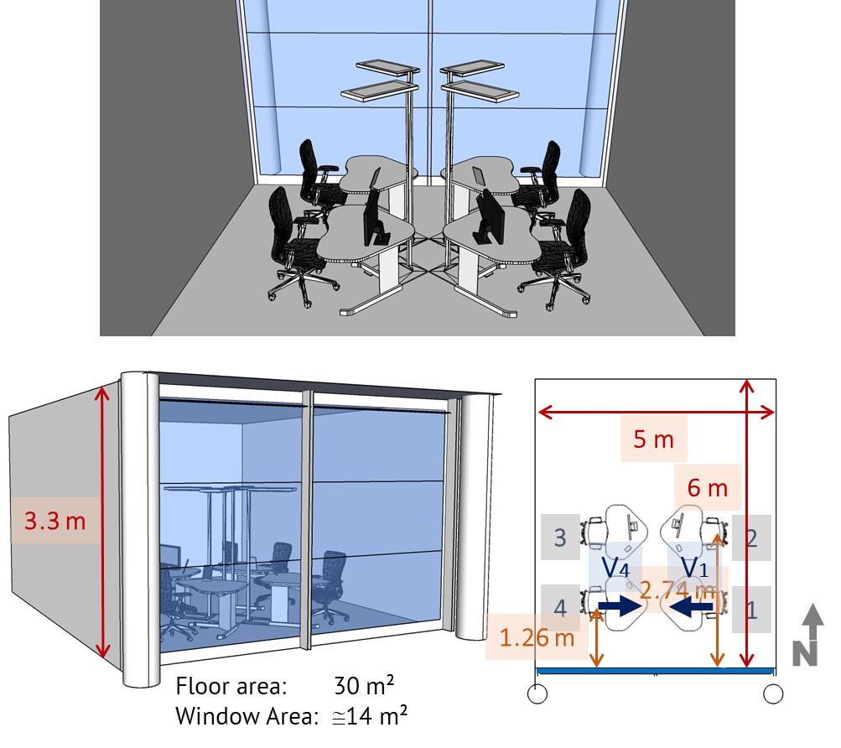

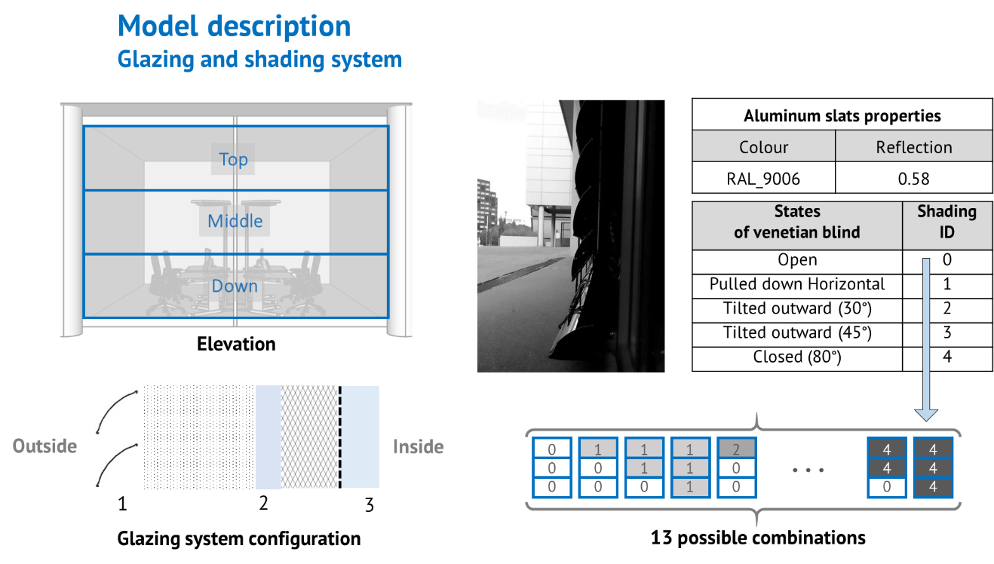

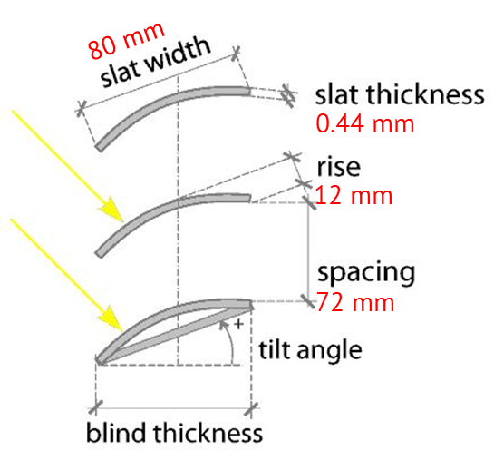

slat radius = 72.67mm

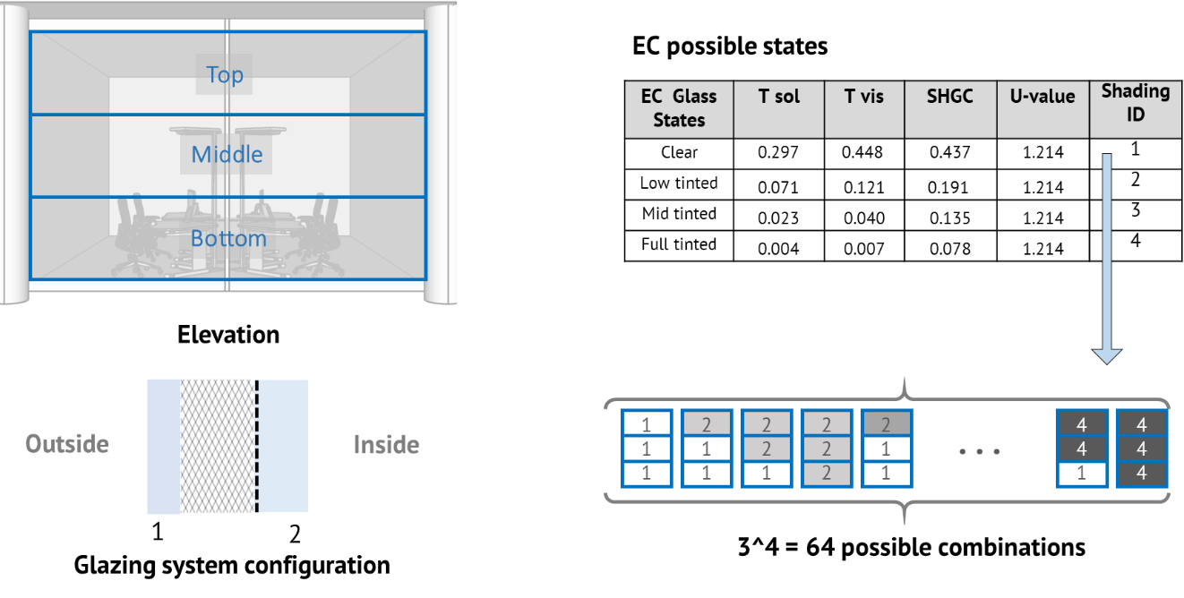

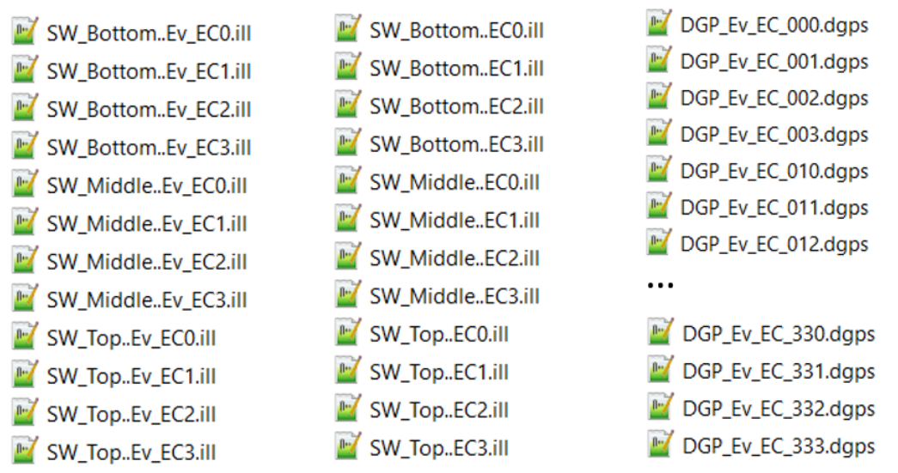

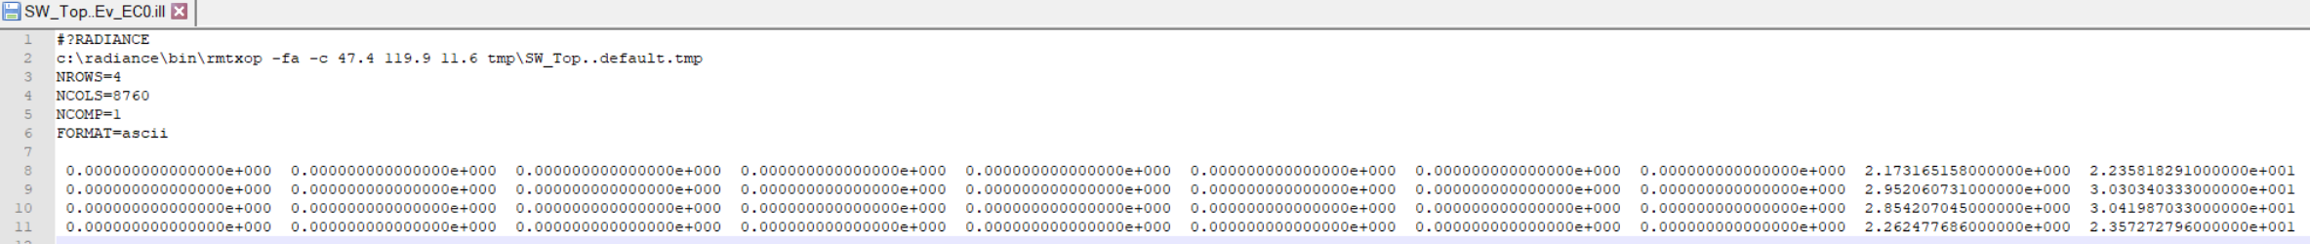

Vertical illuminance [lx] matrix, 4 workplace positions by 8760 hr.

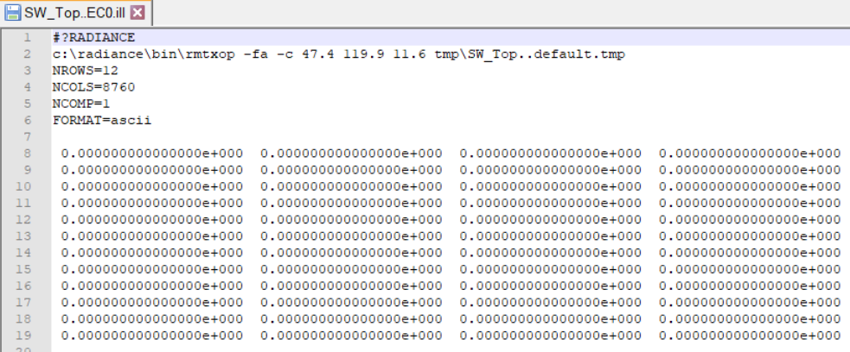

Horizontal illuminance [lx] matrix, 4\*3 = 12 workplace positions by 8760 hr.

Each workplace has 3 sensor pints

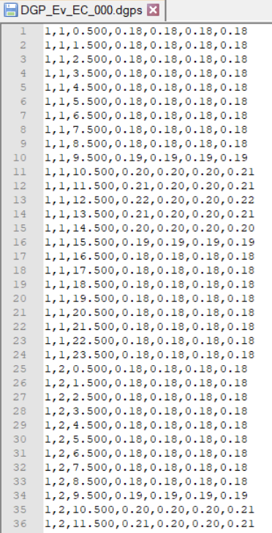

DGPs matrix for every combination: the first 3 values (MM, DD, HH), 4 workplace positions for 8760 hr.